DECEMBER
Tues 1st | Youth Net - Can you please pray for staff health and resilience for The Youth Net team but also schools in general. Schools can be a tough place to work in at the moment
Wed 2nd | Berkswich Methodist Church  St Giles Parish Church and benefice parishes
Thur 3rd | We would welcome prayers for the work going on in the Prison at the moment:  Because of COVID:  Residents are still in lockdown for 23 hours a day, as a result of on-going outbreaks of the virus.  Workshops/Programmes are restricted.  We still have no Chapel services.  Please pray that we will be able to have some Christmas Chapel activities.  Pray for the work being done by the Chaplaincy Team.
Fri 4th | Great Stafford Give Back = Gifts will be being distributed this month as part of the partnership with local businesses.
Sat 5th | Castle Church Parish Church  St John’s Parish Church , Littleworth
Sun 6th | Advent 2 - A voice of one calling: “In the wilderness prepare the way for the Lord; make straight in the desert a highway for our God. Is 40:3 = who will you invite to event on 20th?
Mon 7th | Pray for the University students, as they receive Covid tests which will hopefully allow them to return home to their families for Christmas. Please pray for negative tests, and safe travels. Pray for overseas students returning home and the complications that international travel brings for them. Pray also for the lecturers after what must have been a stressful time at work during the difficult times of the pandemic.
Tues 8th | The Parish of Berkswich are letting the light of the Incarnation shine out through windows decorated with scenes inspired by Christmas carols. Pray that all who see them will draw closer to the Christchild this Christmas.
Wed 9th | Youth Net and Thrive - we will be delivering emotional wellbeing support in the forms of lessons/workshops during December to year 7, 8 and 11
Thur 10th | Youth Net Projects -  Connect Stafford Youth - out on detached Tuesday, Wednesday, Thursday, Friday and alternate Saturdays  IF project - Weston Road, King Edwards and Haven = Monday, Wednesday, Thursday and Friday  Engage = RE lessons this month the Nature of God - 2nd, 7th, 10th, 16th
Fri 11th  Deadline for prayers for January 2021 | Stafford fm Sunrise Service - we need prayers for guidance regarding the radio content we produce for Christmas Day and the lead up to Christmas. We are fortunate in that the directors have given quite a lot of freedom for the Sunday Sunrise team to contribute to Christmas day on the radio, and this year we are hoping to get some pre-recorded content from churches in Stafford, on the radio too.
Sat 12th | Church Lane Evangelical Church  St Lawrence Parish Church Gnosall
Sun 13th | Advent 3: Pass through, pass through the gates! Prepare the way for the people. Build up, build up the highway! Remove the stones. Raise a banner for the nations. Is 62:10 – have you invited anyone to the event on 20th?
Mon 14th | OPERATION CHRISTMAS CHILD UPDATE:  Collection week for shoebox gifts in England has been moved to December 5th to 14th! Please continue packing boxes and dropping them off at Sandon Road Baptist Church - every gift is a precious opportunity to share God's love with a child in need around the world.  Please pray for volunteers needed to process and pack thousands of boxes at our Oldbury Processing Centre, which will continue into the New Year.
Tues 15th | Youth Net Activity Packs - will go out this month to support the Look for light campaign by the Council and also to share the good news about Christmas!
Wed 16th | Prayers for those people who are planning to bring terror and mayhem to others. Pray that the love of God will enter their hearts and cause them to turn away from killing and hurting..
Thur 17th | Let us also pray for peace in USA as the new President is sworn in.
Fri 18th | Prayers, please, for all school children and young people as they finish the first full term of school. Pray for their health and safety during the Christmas Holidays. Pray also for the teachers and support staff, office staff and governors, that they have a healthy break, and take time to recoup their energy after what must have been a stressful time at work during a difficult period in our world.
Sat 19th | Elim Hope Church  St Mary’s Church and St Chad’s Church
Sun 20th | 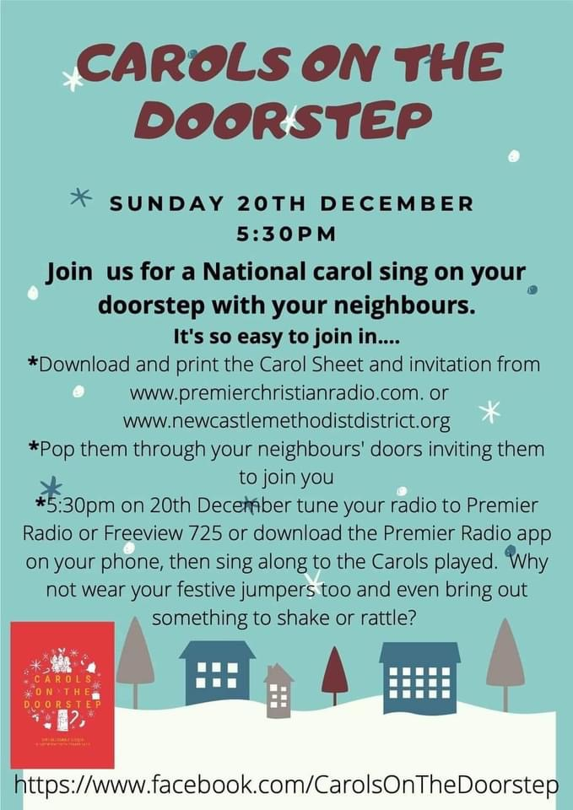
Mon 21st | Harvest Community Church  St Paul’s Parish Church
Tue 22nd | Mid Trent Team of Parishes  St Peter’s Parish Church
Wed 23rd | New Testament Church of God, Doxey  St Thomas and St Andrew, Doxey
Thur 24th | Christmas Eve - When the angels had left them and gone into heaven, the shepherds said to one another, “Let’s go to Bethlehem and see this thing that has happened, which the Lord has told us about.” Luke 2:15
Fri 25th | Christmas Day - 1 In the beginning was the Word, and the Word was with God, and the Word was God. ² He was with God in the beginning. ³ Through him all things were made; without him nothing was made that has been made. ⁴ In him was life, and that life was the light of all mankind. ⁵ The light shines in the darkness, and the darkness has not overcome^{[a]} it. John 1:1-5
Sat 26th | Rising Brook Baptist Church  Stafford Baptist Church (The Green)
Sun 27th | Pray for the covid vaccine. Thank God for those who are working on it, taking part in the trials… Pray for integrity in the distribution across the world. Pray for its efficacy.
Mon 28th | Rising Brook Methodist Church  The Beacon International Centre and Sandon Road Baptist Church
Tue 29th | Salvation Army  Trinity Church
Wed 30th | St Bertelin’s Parish Church  Wildwood Church
Thur 31st | New Year’s Eve – Many will be saying thank God 2020 is coming to a close… Pray for all those who have been ill, bereaved, disappointed and hurt in any way during the past year.  Bring 2021 to God and ask him to bless Love Stafford – all our churches listed above… that our praying will grow in understanding and in urgency.

Maryann

